Jesse Martino

Java Programming Assignment 1

Due 9/10/17

Problem Statement: We were asked to create a new java project where we would have to create code in order to allow a user to enter their First Name, Last Name and student ID number.

Structure Flow:

Step 1 was to create the class in which I would be doing all of the work in.

Step 2 was to see how many variables are needed in the class.

Step 3 was to include the scanner.

Step 4 was to format how the user will enter his information.

Step 5 was to make sure that information is properly stored in the correct variables.

Step 6 was to gather all the information that was entered and display it back to the user.

Implementation:

Step1. In this step, I am thinking about how the code should look. Since it is the very beginning of the project, I made a decision early that only one class would be needed in order to get the problem resolved.

Step2. In step 2, I went back to the problem and counted the total number of variables I was going to need in order to properly solve the issue. I decided that only 3 variables were going to be used. One variable for the first name represented by the letter *s*. The last name would also need a variable and is represented by the letter *p*. And a variable for the student ID number would also need to be created to store the number and was represented by the letter *a*. I also separated the first and last name variables because they were strings where the student ID variable is an integer.

Step3. For step 3, I knew that the user was going to be putting in numbers and letters in the program as inputs so the scanner file had to be imported into the program. This allows the program to take inputs from the user so they can be stored into variables.

Step4 & Step5. This step is all about how the user will see what they are being asked. I prepared the code which will allow the user to see one question at a time asking him/her a question and requiring a response. Once the user enters the response to the question, the program will store the information they just entered into one of the variables I mentioned earlier. Once the information is properly stored in the variable, then the program will ask the user the next question also requiring a response before it moves onto the final question.

Step6. This step is mainly about the display to the user. This step takes all the information entered from user and prints it back to the user in a readable, neat format. While the code for the program uses the variables, the system knows what information is currently stored in the variables and properly displays the information back to the user.

Test Description and Results:

This program does accurately solve the problem at hand. It does allow the user to enter their first name, then enter their last name, and then enter their student ID number. Once all the information is gathered the program displays the information back to the user and solves which solves the issue. The program was tested multiple times with various names and numbers without any major errors. One small issue I did find was possible mistakes the user could encounter when entering their information incorrectly. For example, entering any non-whole numbers or negative numbers was one common occurrence.

Epilogue:

Overall, I thought this assignment was helpful. I helped me get familiar with coding on NetBeans and learning java and how to assemble a program using java. One section that took a little research was implementing a scanner for the program. I was new to the topic but with a little help from the textbook, I was able to find a solution.

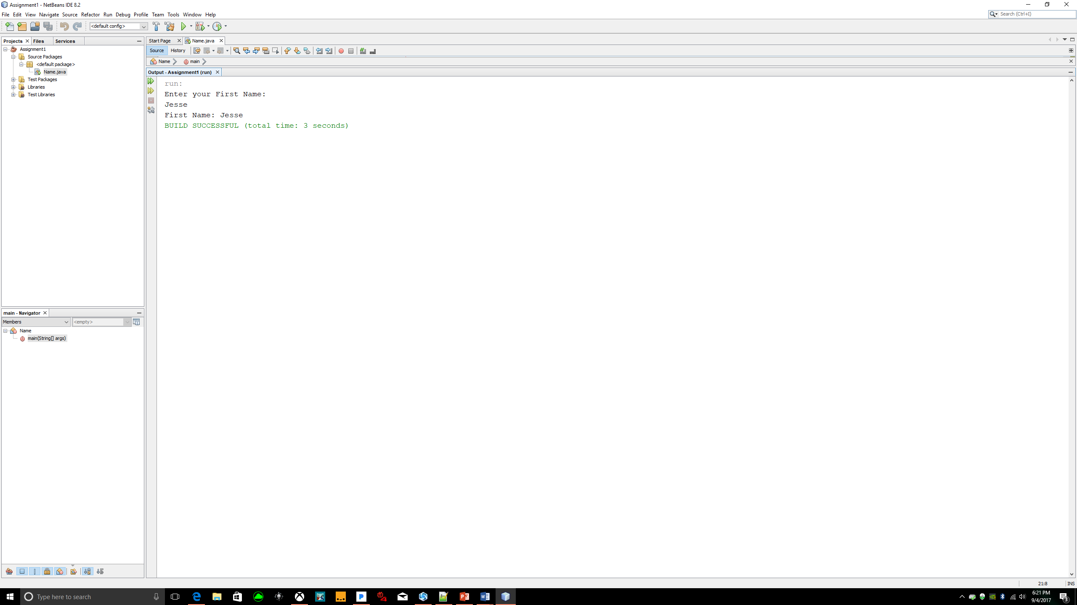Task #1

Here I created a class that would display a name when entered into the program. The program displays the name after it has been entered. Below is the code for the solution to task 1.

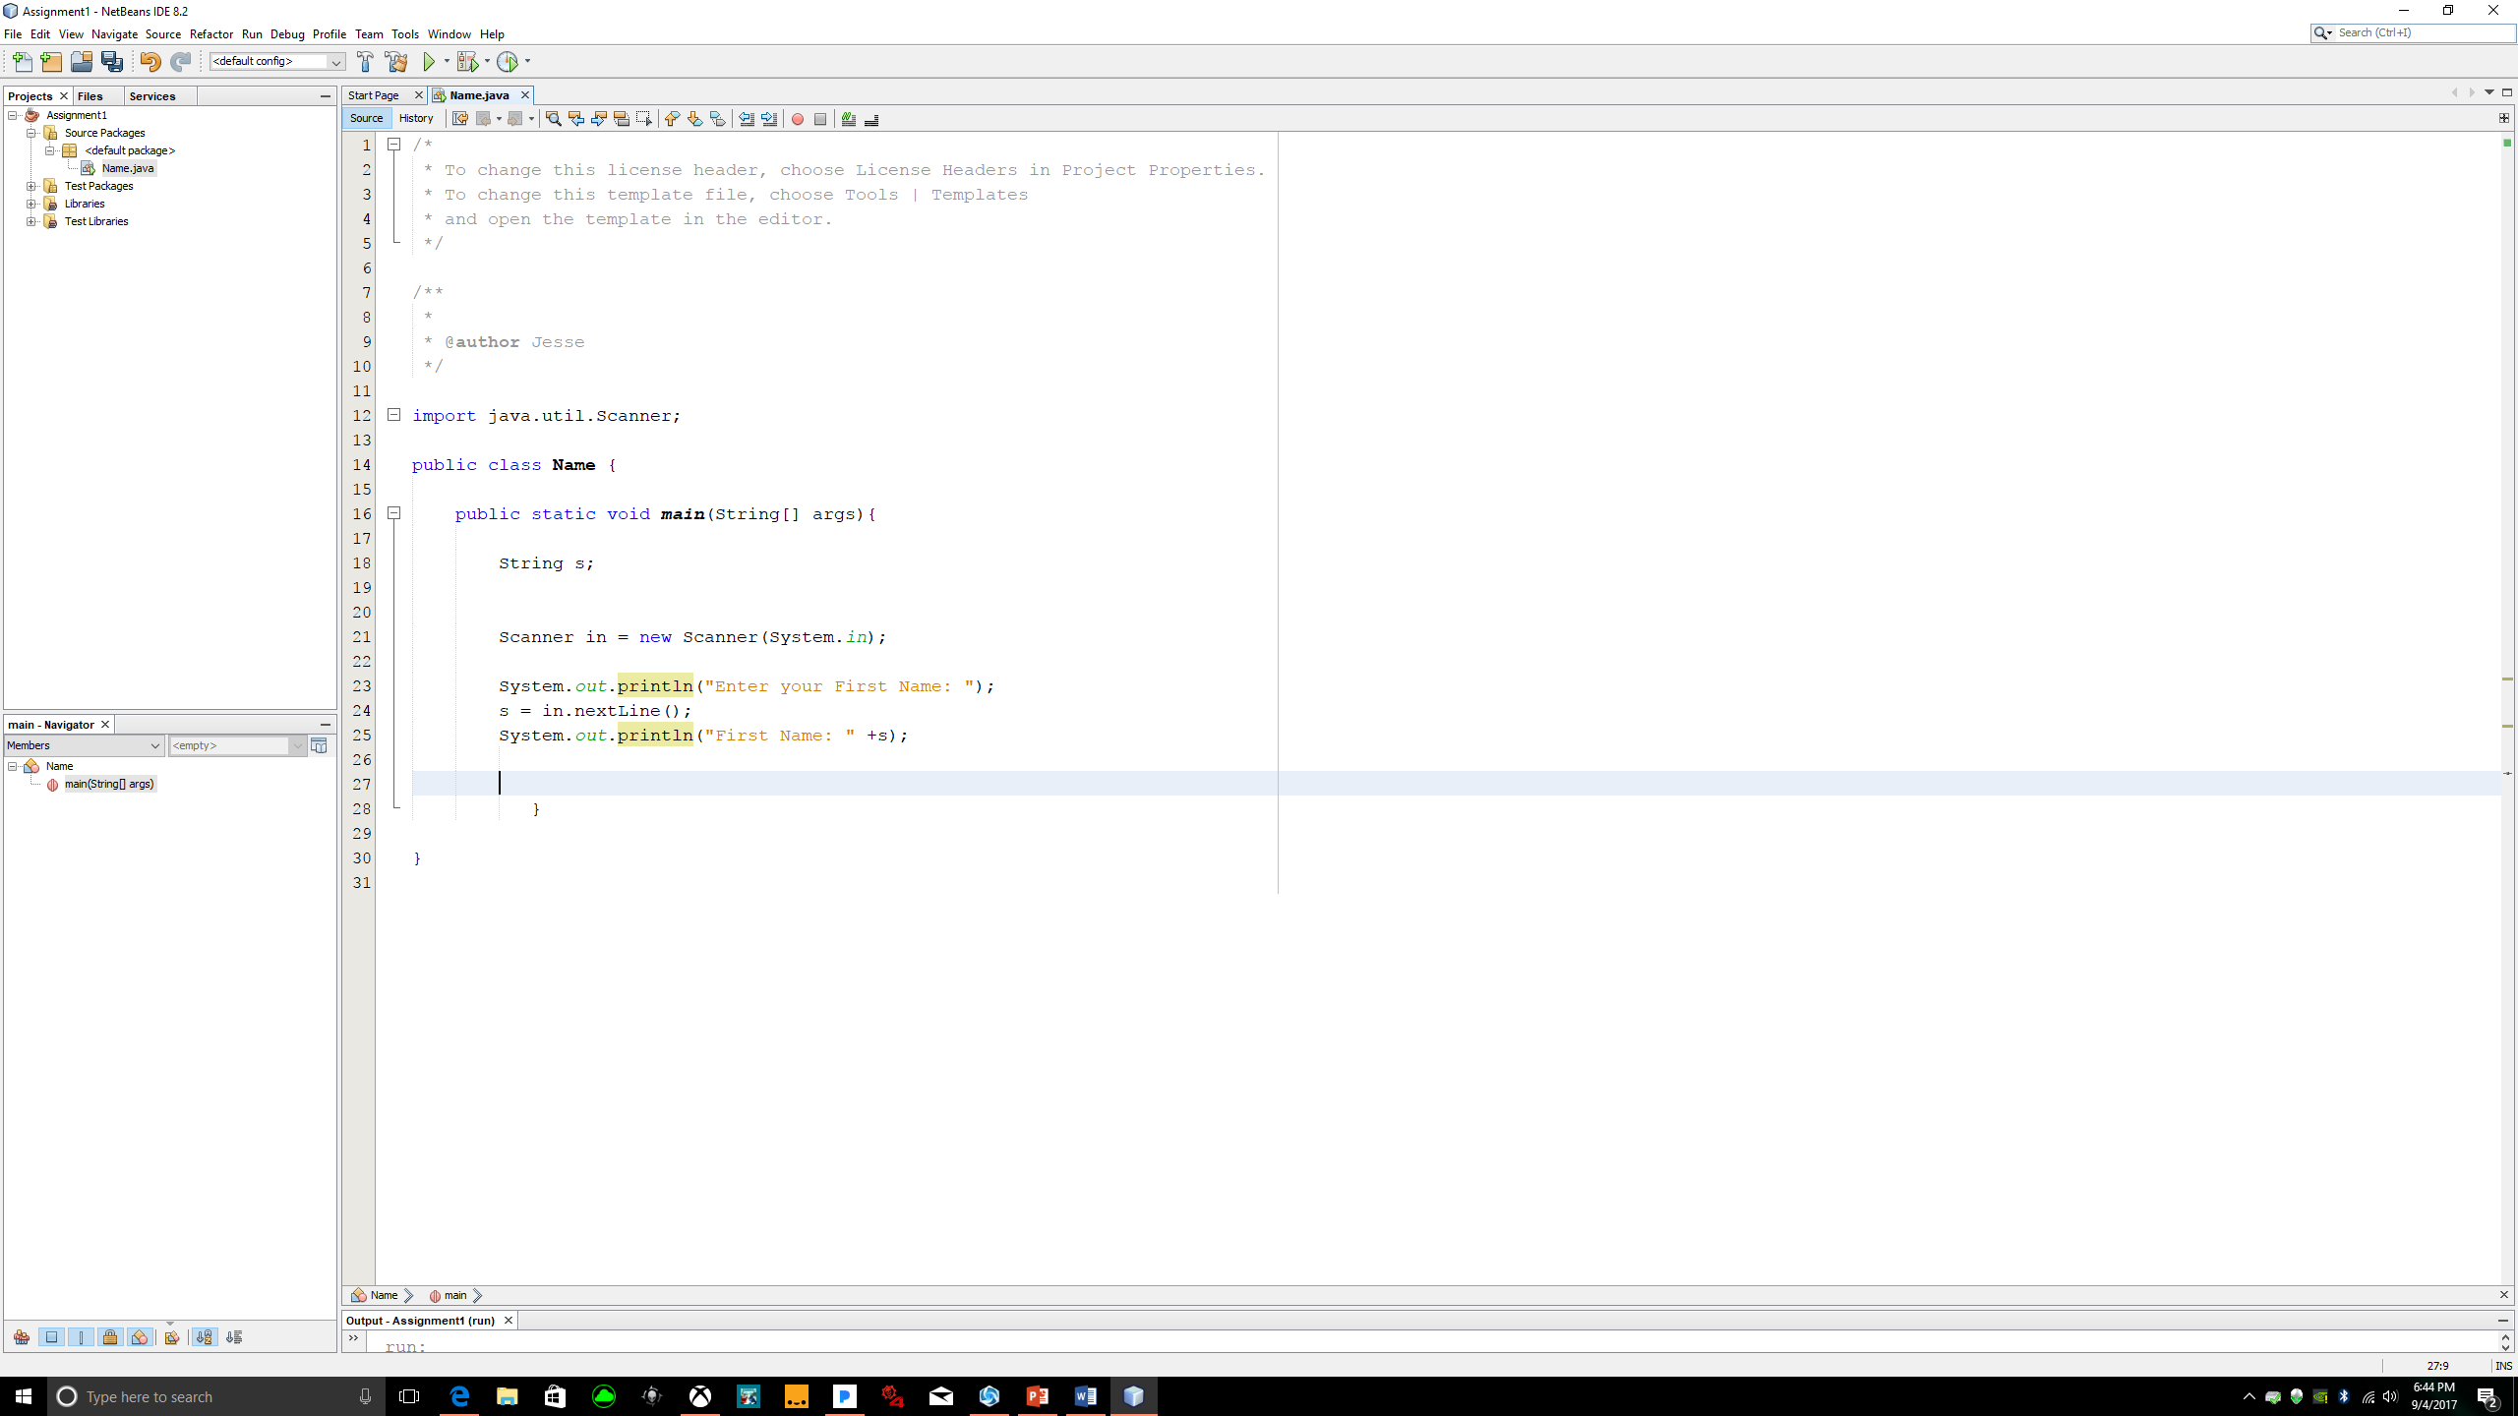

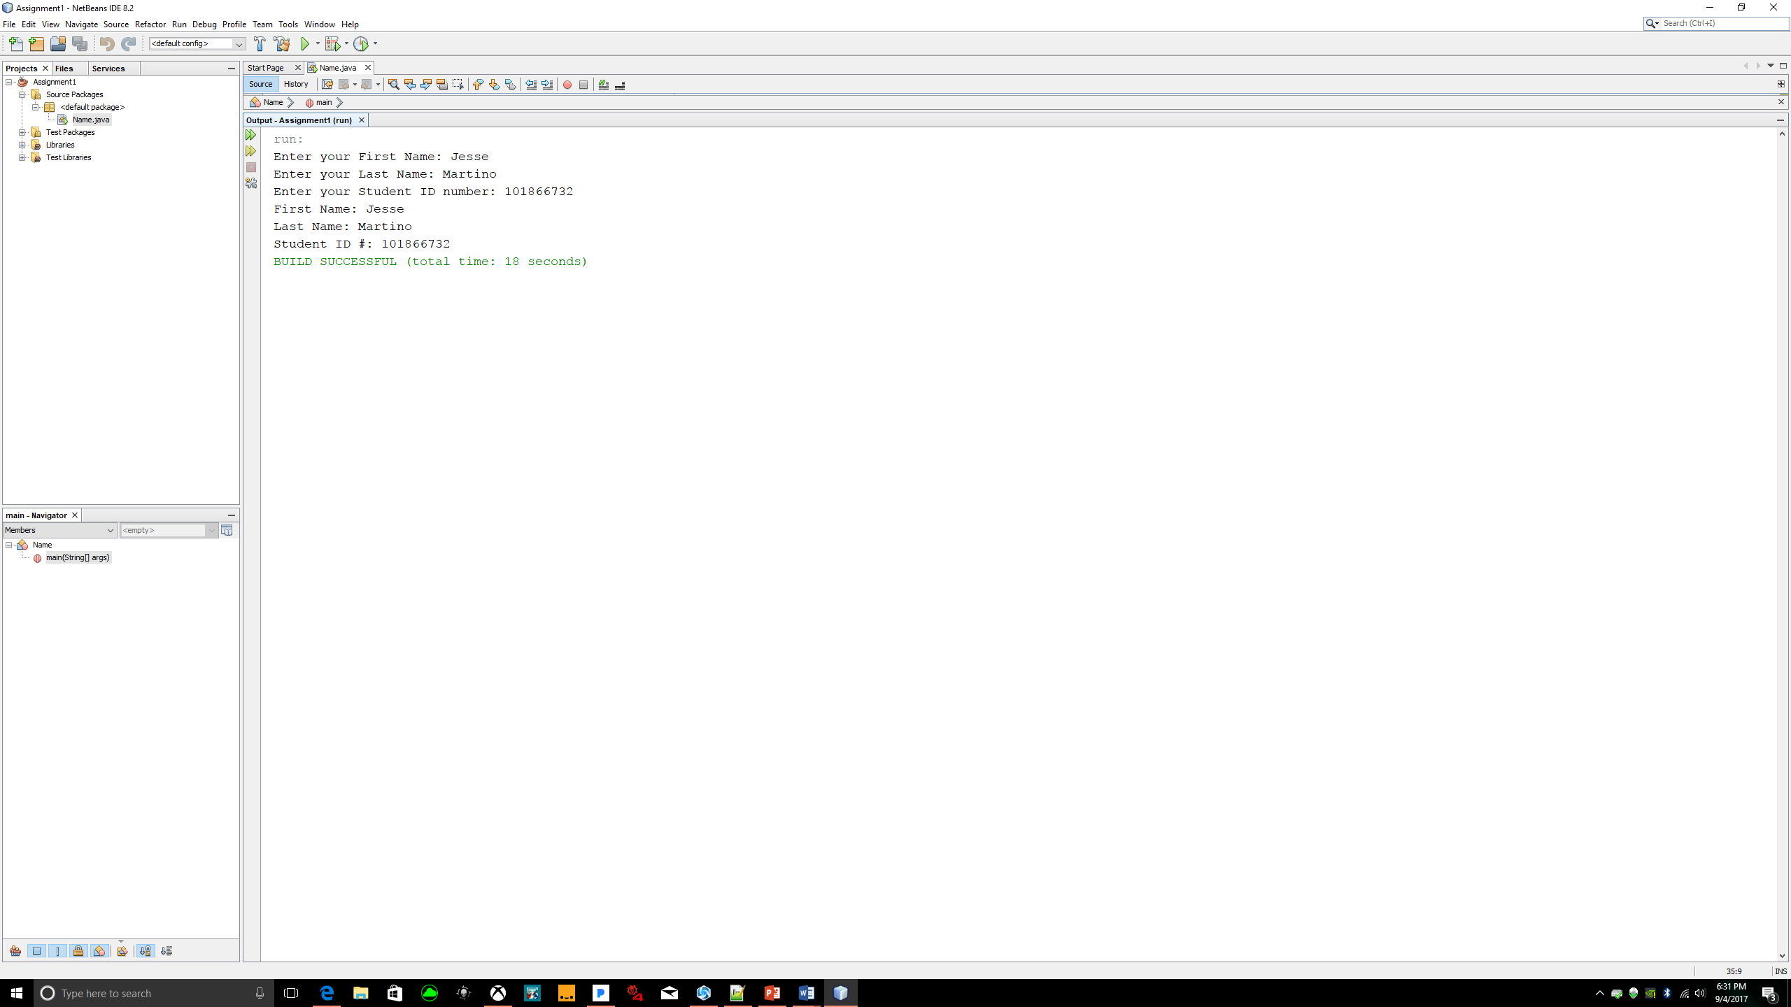Task #2

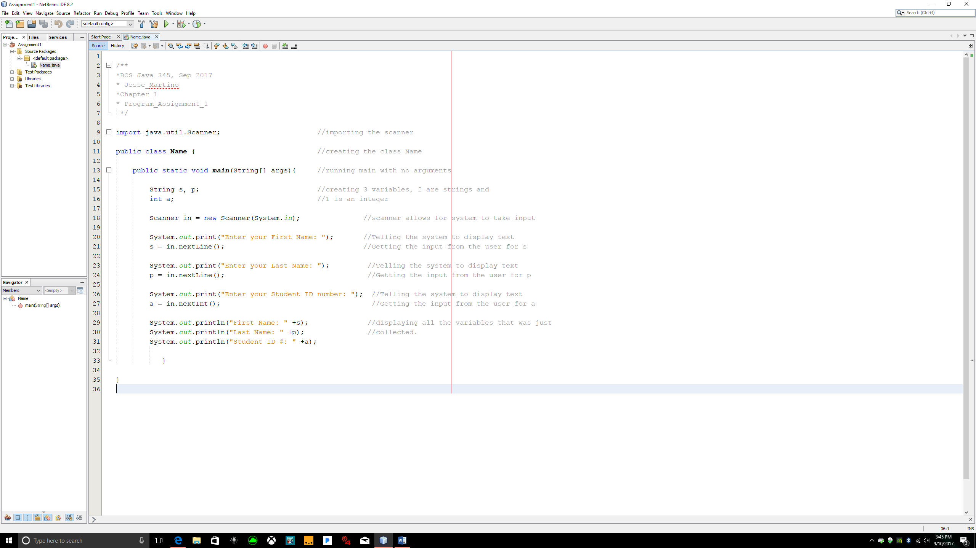In task 2, I used the same program from task one and added 2 additional inputs to the program. I also added the last name variable and the student ID number variable. Below is the code for the for the solution.